Voltage in Series and Parallel Circuits

Construct these circuits and measure the voltage for each ammeter.
1
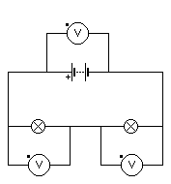

Voltmeter | Voltage  (V)
1
2
3

3
2

In a series circuit the voltage

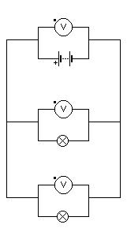
4

Voltmeter  5 | Voltage  (V)
4
5
6

6

In a parallel circuit the voltage
Voltage in Series and Parallel Circuits

Construct these circuits and measure the voltage for each ammeter.
1

Voltmeter | Voltage  (V)
1
2
3

3
2

In a series circuit the voltage

4

Voltmeter  5 | Voltage  (V)
4
5
6

6

In a parallel circuit the voltage

